Resource requirement-human resource and training
Because our business model will provide personalized training and guidance for working out, it is required for us to have a large number of personal trainers (PTs). As such, it is important to build a detailed human resource planning for recruiting and training our team of personal trainers which should have both males and females at different ages with different sorts of expertise in order to meet the diverse needs from our potential customer. First of all, we will recruit a large number of candidates and open to both individuals who have already obtained a gym certification such as Certificate IV in Fitness (SIS40215) or Diploma of Fitness (SIS50215), which are required certification to become a personal trainer in Australia according to the state law (Fit Education, 2020), and those who have not yet acquired such certification. Given that we will need a huge number of personal trainers to fit with our business model, those who have not yet received the certificate will still be considered based on their health checking test (i.e. candidates without certification but with good health conditions will be considered beside those candidates who are already certified). We will screen and check several physical conditions (e.g. weight, height, etc.) to ensure the chosen persons have good capabilities of doing their job in the future. After being selected, these people will be sent to a local institution, such as Victoria University Polytechnic in Melbourne where offers short-term fitness program to get the Certificate IV in Fitness for training health professionals with gym skills. The fitness program is typically between 9 months and 18 months. The cost for this training human resource, which may be costly, will be reimbursed on the basis of the salary when these trained personal trainers start to work for our business (i.e. fee to pay for training them will be partially deduced from their monthly salary in the future). Therefore, recruited candidates who have yet to get the certificate have to be committed in the contract about the terms of training and cost of training program.
At the same time, in order to effectively mange the human source, we will develop a mobile app that includes the information of all personal trainers at our gym center, which might include age, gender, height, weight and other health-related indicators to help our clients choose the best person that is most suited to them. Our customers have to register an account on this mobile app and provide their health information as well in order to help personal trainers build the suitable working-out program for them. All communications between clients and personal trainers will only be made through the app and no informal channel other than the app will be permitted to avoid unexpected situation (e.g. sexual harassment). Moreover, as our business scope expands into yoga as well, hence our training program will also be focused on training yoga therapy to provide this service targeting middle-aged female segment in Melbourne.
Location consideration
Location plays an important role in determining the success of our business model because choosing a strategic location allows us to target mass-market (i.e. different segments of potential clients) as well as shorten the distance when guests have to go to our center to pick up the working up and gym equipment and when personal trainers have to move from the center to the home and private residence of their client. In this regard, the population density should be considered to be a primary condition when selecting the location to open our office building in the area of Melbourne. Table 1 below lists the top 10 most densely populated areas of Melbourne. Although the center downtown of Melbourne seems to be the ideal choice due to its population size, population density and growth, placing our office building in this area is risky in at least two ways. First, this is a very expensive area, which can be regarded as the most expensive area in Australia, thus the cost for renting and using facilities (e.g. water, electricity bill) will be very high. Given that our Home Gym does not position itself as an extremely luxurious and premium service and that clients actually do not come to our office often to use our building, opening the office building in this center downtown is too costly for us in the initial stages of this business, especially when a large amount of cost will be allocated to training fee to reach a large number personal trainers a mentioned previously. Second, the level of competition in this area is very high as there are many fitness centers within this area, thus residents within this downtown area might have lower need and demand for working out at home because there are a variety of available options for them to choose instead of having to work out at house. Thus, our business will be competed fiercely by these rivals if opening the building here. Taken together, we will not choose the center downtown of Melbourne given the above-mentioned reasons. As such, to lower the risks of our business failure and competition as well as reduce operation cost, we decide to pick Carlton to open our office. This is an inner-northern suburb of Melbourne with the second highest population density and population growth as being seen in Table 1 beneath. Also, the renting expense in this area is relatively cheaper as compared with that in downtown of Melbourne. Therefore, opening the office building in Carlton helps to reduce risk of competition as well as lower the operation cost for our business. When our business is successful in the future, we will consider to expand the office branch into other areas in the list.
Table 1. Top 10 most densely populated areas of Melbourne
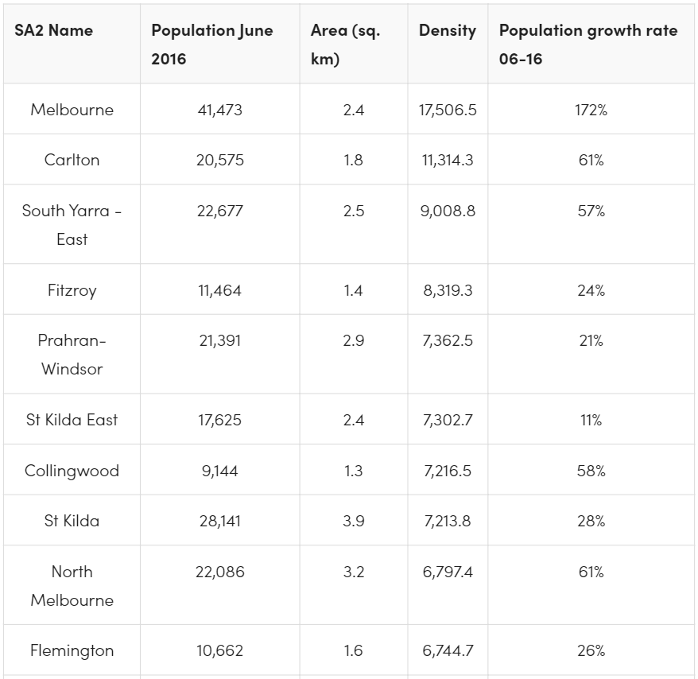
Source: Taylor (2017)
Green sustainability
Because our business model is reliant on the concept of sharing economy (i.e. sharing gym equipment between clients in order to optimize the use of equipment and in turn minimize the use of energy and other resources), sustainability is a key characteristic of our business to help us stand out from the market as well as to differentiate our business from other competing players in Melbourne. It is true that there are many gym centers out there in Melbourne, thus being sustainable will be a key differentiating point to shape our competitive edge as previous research has shown the strong link between sustainable commitment and competitiveness of business (Cantele and Zardini, 2018). Consistent with this business philosophy, our building for personal trainers to move between our office and clients’ homes and private residences will focus on reducing energy use and optimizing sustainability. The focus on sustainability will be related to the two following main pillars: green energy solutions; energy audit and green technologies.
Green Energy Solutions
Because we plan that our building will open 24/7, this will consume a lot of energy and thus ensuring the implementation of green energy for our building becomes an essential consideration. In particular, we intend to employ a number of solutions associated with saving the energy use. First, with regard to the power and electricity, we consider using the solar energy rather than the normal electricity from the Australian national electricity grid. Solar energy can be regarded as an eco-friendly and renewable source of energy that is friendly to most of buildings. These solar panels will be installed on the roofs of the rent building in order to generate the power and electricity from the natural sun for our office. In fact, we have to maintain our gym equipment in good and sanitized condition, which is particularly important during this epidemic time when it may be possible that the virus can be transmitted via the equipment from one client to others, hence lighting, air conditioning and event heating will be used a lot and the use of solar energy can be a good solution dealing with this high demand for energy use. On the other side, we will divide our building into different floors and rooms and each will include different kinds of equipment to adjust our maintenance conditions accordingly. Overall, the use of solar electricity not only helps us to cut down on our bill but also corresponds with our green efforts in running this business project. It is reported that Australian people become more and more sensitive to sustainable topic, especially after the massive bushfires in late 2019 and early 2020 (Readfearn, 2020). As such, our emphasis on sustainability would be critical to build our green brand image to local target customers.
Energy audit and technologies
In addition to using solar energy, energy audit becomes an integral part of our sustainability commitment. Basically, energy auditing is the process of evaluating and inspecting the consumption of energy for the whole building and facilities as well as equipment in order to assure thee efficient use of energy. The base for auditing our energy consumption is that it can reduce the energy input but does not compromise the output or service quality provided to our clients (Dhooma and Baker, 2012). As part of our planning, we intend to purchase some professional systems and software that help us better audit the efficient consumption of energy. One potential software package to be considered by us is EMAT, which is a clouding-based program that allows us to analyze the use of energy with figures, workflow and accompanied reports and all sorts of data can be saved on its cloud for future improvements. In fact, the implementation of clouding is also congruent with our sustainability efforts because clouding method can help to store and manage data more effectively and efficiently as compared with the traditional solutions that save and monitor the data manually on computers, which will take a lot of energy and resources (Gunasekaran, Subramanian, and Rahman, 2015). Technologies will also be used in order to reduce the “lead time”, a concept that is related to the time gap from starting to deliver the service to completing the service process (Jha and Shanker, 2009) (i.e. the time when clients make their schedule to pick the equipment up or make the training appointment until when they actually come to our office to take the selected equipment or until when the personal trainer comes to their home/private residence). In this regard, we will build a “big data” in order to allow us to analyze information about health indicators, average time for service process and the like. This will enable us to improve our service process better and adjust our training programs in order to reduce the lead time.
Another vital element of implementing sustainability is the reduction in waste. Therefore, beside energy efficiency usage, waste reduction is another focus of our sustainability. Accordingly, we will comply with the 3R framework: reduce, reuse, and recycling. We will first reduce the use of unnecessary things to reduce the waste from the building being released into landfills. We will reuse all materials that can be reused in order to minimize our waste amount. We will send out our old equipment, which cannot be used anymore, to recycling centers such as Bingo Recycling Center in West Melbourne, Atlas Recycling, or Recycling Centre Melbourne University in order to turn our old equipment into different reusable materials.
Supply chain
We will focus on both backward and forward in our supply chain which is commensurate with the emphasis on sustainability above (see Figure 1 for details of our supply chain process):
Backward supply chain: in line with the orientation toward sustainability business model, our business will partner with local supplier that can supply us eco-friendly gym equipment. In gymnastic sector, the use of green equipment is on the rise, these kinds of equipment are made from recycled and eco-friendly materials in order to reduce their impact during the manufacturing and using process on the environment (i.e. old equipment will not go to landfills but can be recycled). In the Australian and New Zealand market, Synergy Fitness is a leading gym equipment distributor that can supply eco-friendly equipment for yoga & workout. Orbit Fitness is also another reliable supplier of gym equipment that our business will consider.
Forward supply chain (vehicles for commuting): consistent with the above focus on sustainability, for travelling between the office building and clients’ homes and private residences, our personal trainers will be provided with electric scooters, this is a flexible and eco-friendly solution that helps us to save cost on transportation as well as to be aligned with our focus on sustainability as the key competitive edge of our business model.
Figure 1. Supply chain process of Home Gym
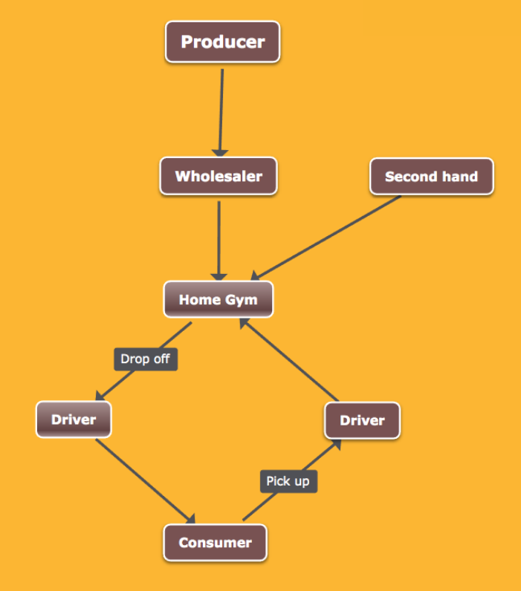
Service process design
We briefly design the process of our service business model which is composed of the eight consecutive steps as follows:
Step 1: customer downloads and installs our mobile app which integrates all related information
Step 2: customer registers for an account, which is free and allows them to have the access to some of free training materials (premium materials must be paid in the form of subscription fee)
Step 3: after being exposed to the features and training materials of our business, customer will decide to pay for our service, which includes registration fee that will be renewed annually as well as monthly installment fee. Moreover, additional fee will be charged if clients damage our gym equipment.
Step 4: after successfully purchasing our service, customer will be able to choose the customized program that s/he wants (e.g. normal workout or yoga), and their preferred personal trainer based on their own preference and some other characteristics (e.g. gender, age, expertise, height, weight characteristics of the personal trainer)
Step 5: our frontline employees at the office will contact the registered customers via phone or email in order to confirm the contract. Afterwards, our managers will make an evaluation and confirm if the personal trainer chosen by the customers can be approved or not. If not possible, we will find other alternatives based on customers’ preference and suggest to the customers a shortlist for their final decision.
Step 6: there will be no personal communications and contacts between customers and personal trainers as noted formerly in order to avoid sexual harassment and similar unexpected things. All the communications and documents about the training and guidelines will be made available via our official mobile app. This mobile app will also the place storing all related data about both personal trainers and customers to help build our “big data” database as we mentioned above.
Step 7. The detailed schedule will be made based on the time availability of our personal trainers and the availability of the equipment at our building. Personal trainer will come to customers’ home and residence according to the schedule, there will be no extra time beyond the fixed schedule. In case customer wants to work out alone, s/he will arrange the schedule in advance to go to our office to pick up the equipment. Late return of equipment will be penalized based on the late length and any significant damages will also be fined.
Step 8. Customers will be able to send back their feedback and rating about their current personal trainer on the monthly basis. Based on the received feedback, our managers will evaluate the performance of personal trainers for compensation and bonus or decide to change another personal trainer if customers demand to do so and are unsatisfied with their current one.
Layout consideration
Because our business model is reliant on the concept of sharing economy, the working-out activities will basically not be taken place in our building as noted earlier. That is, the office is only the place to store and maintain our gym and yoga equipment and for customers to come there for any inquiries or getting guidelines and other basic services of our business. As such, we will not need a large space and big building, which means that the layout of our building will be very simply and consistent with the focus on green building as we mentioned earlier. We plan to rent a building with the three floors: first floor is our main office and meeting room; second floor is our place to store major gym and yoga equipment; third floor is the venue for training activities because our team of personal trainers will have to be trained to upgrade their skills on a regular basis (e.g. monthly). The regular training sessions shall also be used so as to evaluate their performance for promotion and compensation.
References
Cantele, S. and Zardini, A. 2018. Is sustainability a competitive advantage for small businesses? An empirical analysis of possible mediators in the sustainability–financial performance relationship. Journal of Cleaner Production, 182, pp. 166–176.
Dhooma, J. and Baker, P. 2012. An exploratory framework for energy conservation in existing warehouses. International Journal of Logistics Research and Applications, 15(1), pp. 37–51.
Fit Education, 2020. HOW LONG WILL MY PERSONAL TRAINER COURSE TAKE? [Online]. Available at https://fiteducation.edu.au/how-long-will-it-take-to-complete-my-personal-trainer-course/
Gunasekaran, A., Subramanian, N. and Rahman, S. 2015. Green supply chain collaboration and incentives: Current trends and future directions. Transportation Research Part E: Logistics and Transportation Review, 74, pp. 1–10.
Jha, J.K. and Shanker, K. 2009. Two-echelon supply chain inventory model with controllable lead time and service level constraint. Computers & Industrial Engineering, 57(3), pp. 1096–1104.
Readfearn, G. 2020. Australia after the bushfires. [Online]. Available at: https://www.theguardian.com/environment/ng-interactive/2020/jul/29/australia-after-the-bushfires-aoe
Taylor, A, 2017. Census 2016: the 20 most densely populated areas of Melbourne. [Online]. Available at https://www.urban.com.au/news/census-2016-the-20-most-densely-populated-areas-of-melbourne

